Question 6.1

To monitor one’s score change, one can type in the proportion of homework, quizzes, group projects, and exams in the final scores to monitor it in real-time. Then, use this model to calculate the proposed final score with all the scores up to now. Each time a new score comes out, type it in and observe whether it will improve or reduce the final score. If this trend lasts, it will touch the threshold.

We will apply our mean score that is satisfying enough in the past semesters as the critical value and the threshold to be one level of score lower than the critical value to be the threshold. We suppose CUSUM will have a positive move; thus, if it drops below the threshold, we will consider changing the learning method or conducting a thorough review of this course.

Question 6.2.1

**Method 1:**

First, we use the average temperature of each summer (July and August) as the baseline temperature by calculating the average temperature for each year, which is used to determine the extent of the subsequent temperature drop. Second, we calculate the difference in temperature relative to the baseline temperature for each day in sheet 2. Subsequently, we calculate the cumulative sum of the temperature deviations for each day according to the CUSUM method, which is used to track the trend of temperature changes (sheet 3). Eventually, we plotted a line graph based on the cumulative sum and visualized a significant drop in temperature on **September 1** of each year.

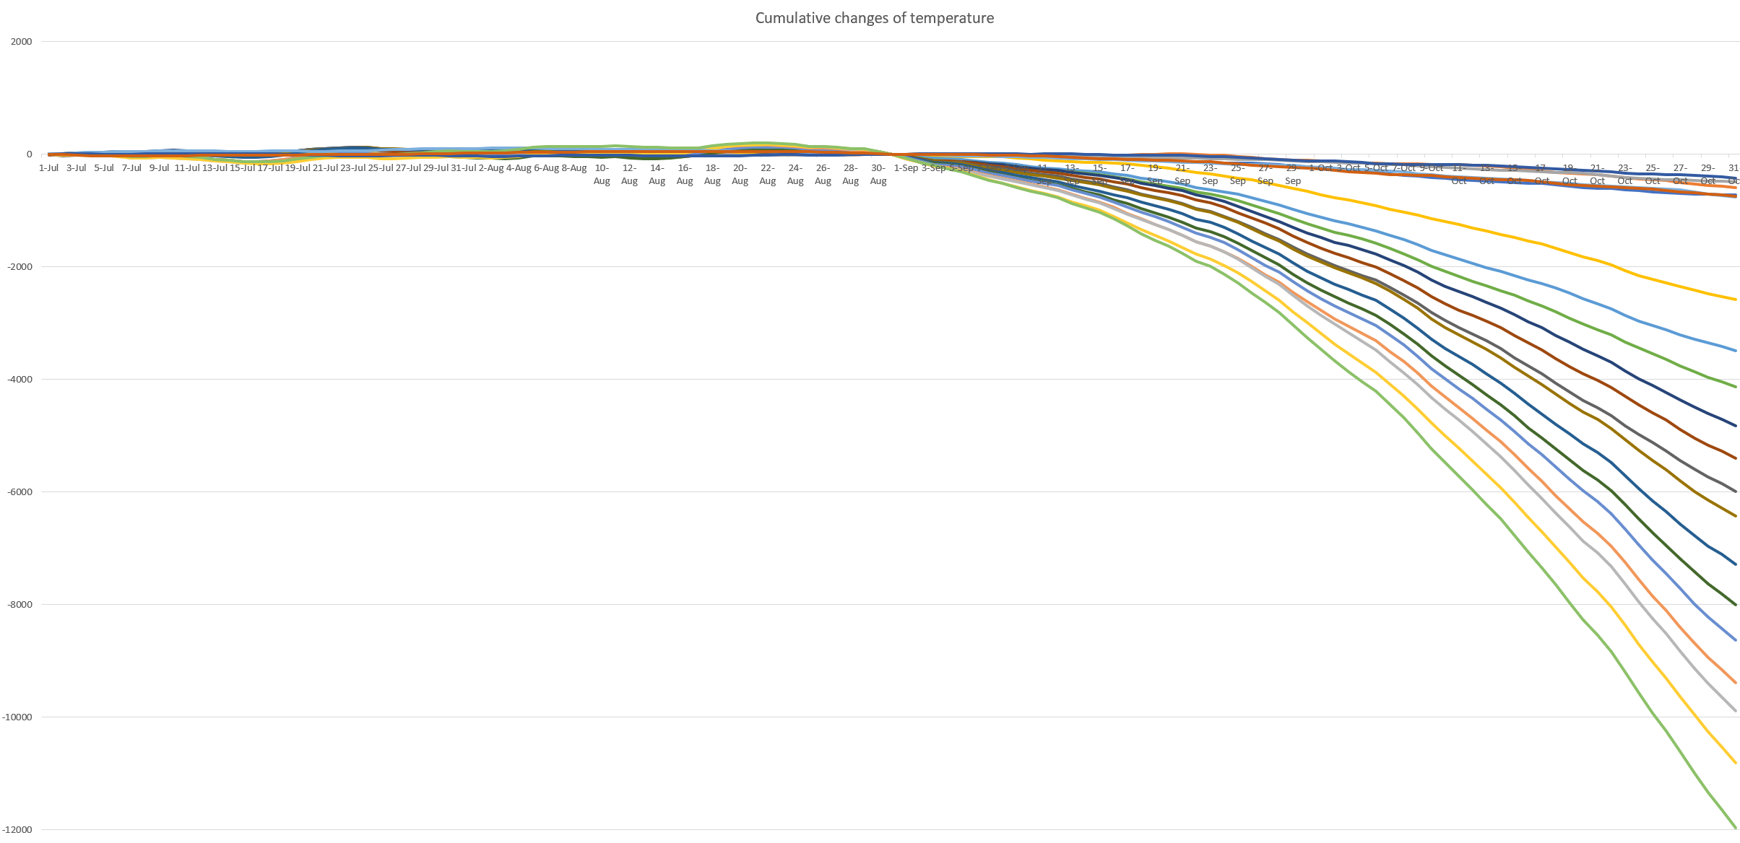

Figure Cumulative changes of temperature

**Method 2:**

Supposing summer ends by August 8th every year, which is the date that the Sun reaches 135° in ecliptic longitude. Thus, we get our critical value (mean) by taking average of the temperature from July 1st to August 8th every year. And we take the value C by calculate the standard deviation of all temperatures by the mean. According to the function of St = max {0, St-1+(Xt-μ-C)}, setting S0 = 0, we can find the CUSUM of all dates by different years. The standard of summer ends is supposed to be the date that St reaches zero and never return to zero in this year. Thus, we get a list of summer ends, which is different in each year.

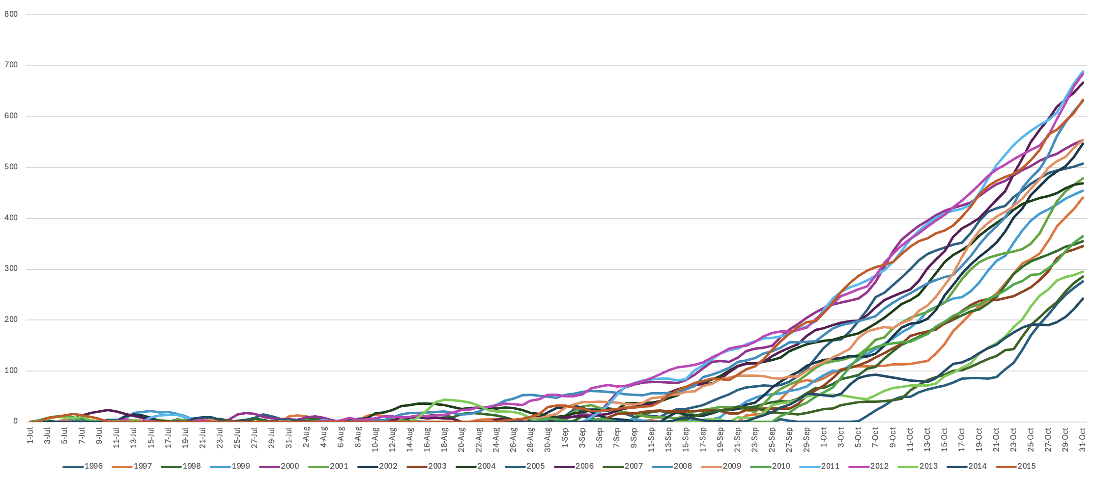

Figure Cumulative changes of temperature 2

Table Date of summer ends

# 

Question 6.2.2

Use a CUSUM approach to make a judgment of whether Atlanta’s summer climate has gotten warmer in that time (and if so, when).

Answer:

To judge whether summer climate has gotten warmer, we need to plot a CUSUM chart. The CUSUM chart plot shows an upward trend, which means temperatures in later years are consistently higher than the baseline, the climate gets warmer. Now let use R to plot the CUSUM chart.

**Methodology of the code：**

First, we load data and transpose the dataset to have years in rows. Then we create a vector to store the July temperature for each year and calculate the data as baseline mean.

Second, we calculate deviations from the baseline, and then sum the deviations of each yeas, the results is the cumulative sum of deviations.

Third, we use blue line as cumulative sum of deviations of each year, red line as baseline reference.

**Discuss:**

The CUSUM plot is shown as figure 3,

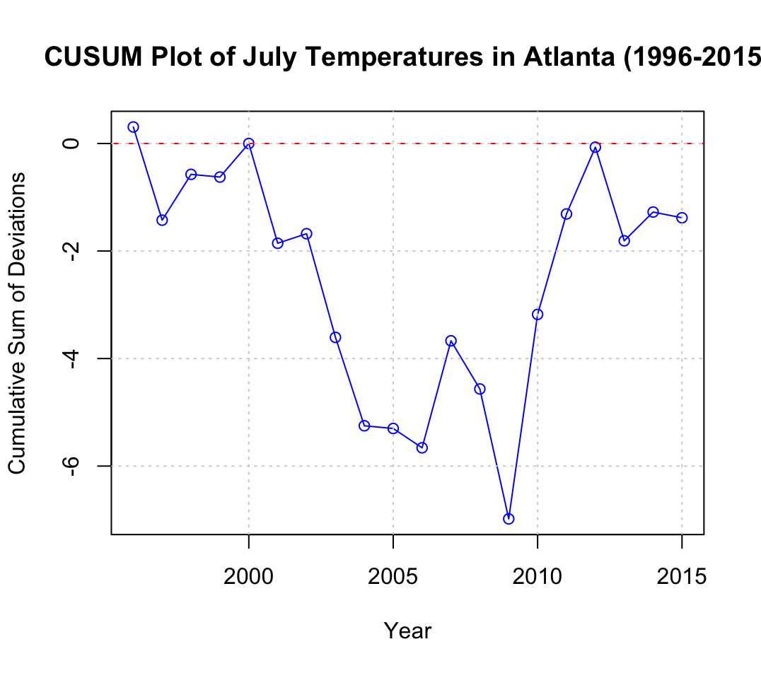

Figure CUSUM Plot of Temperature in Altana(1996-2015)

**From the plot, we can see from1997-2000,2006-2007,2009-2012, the chart has an upward tendency, it means the summer weather in that time gets warmer.**